www.yournh.ca sample article.

Neighbourhood Houses and Social Connections
Neighbourhood houses are a hub in the local community where people can meet their neighbours and develop new friendships. Their doors are open to everyone in the community, and they keep their doors open for many hours so that all members of the community can drop by to use their facilities. Use of the neighbourhood house is often free or carries a minimal charge.
Neighbourhood houses also attract a wide variety of community members to their facilities due to the variety of programs and activities. These include services like childcare groups, English as a Second Language courses, tutorial groups for students, and employment counseling. Alone, these service oriented programs are not what make the Houses unique. They also combine these services with cultural and other expressive activities like art classes and displays, local music groups and performances and mutual help groups for women and seniors.
Neighbourhood houses are ideal locations for making connections in the community due to their open doors and the variety of programming and activities of interest to all.
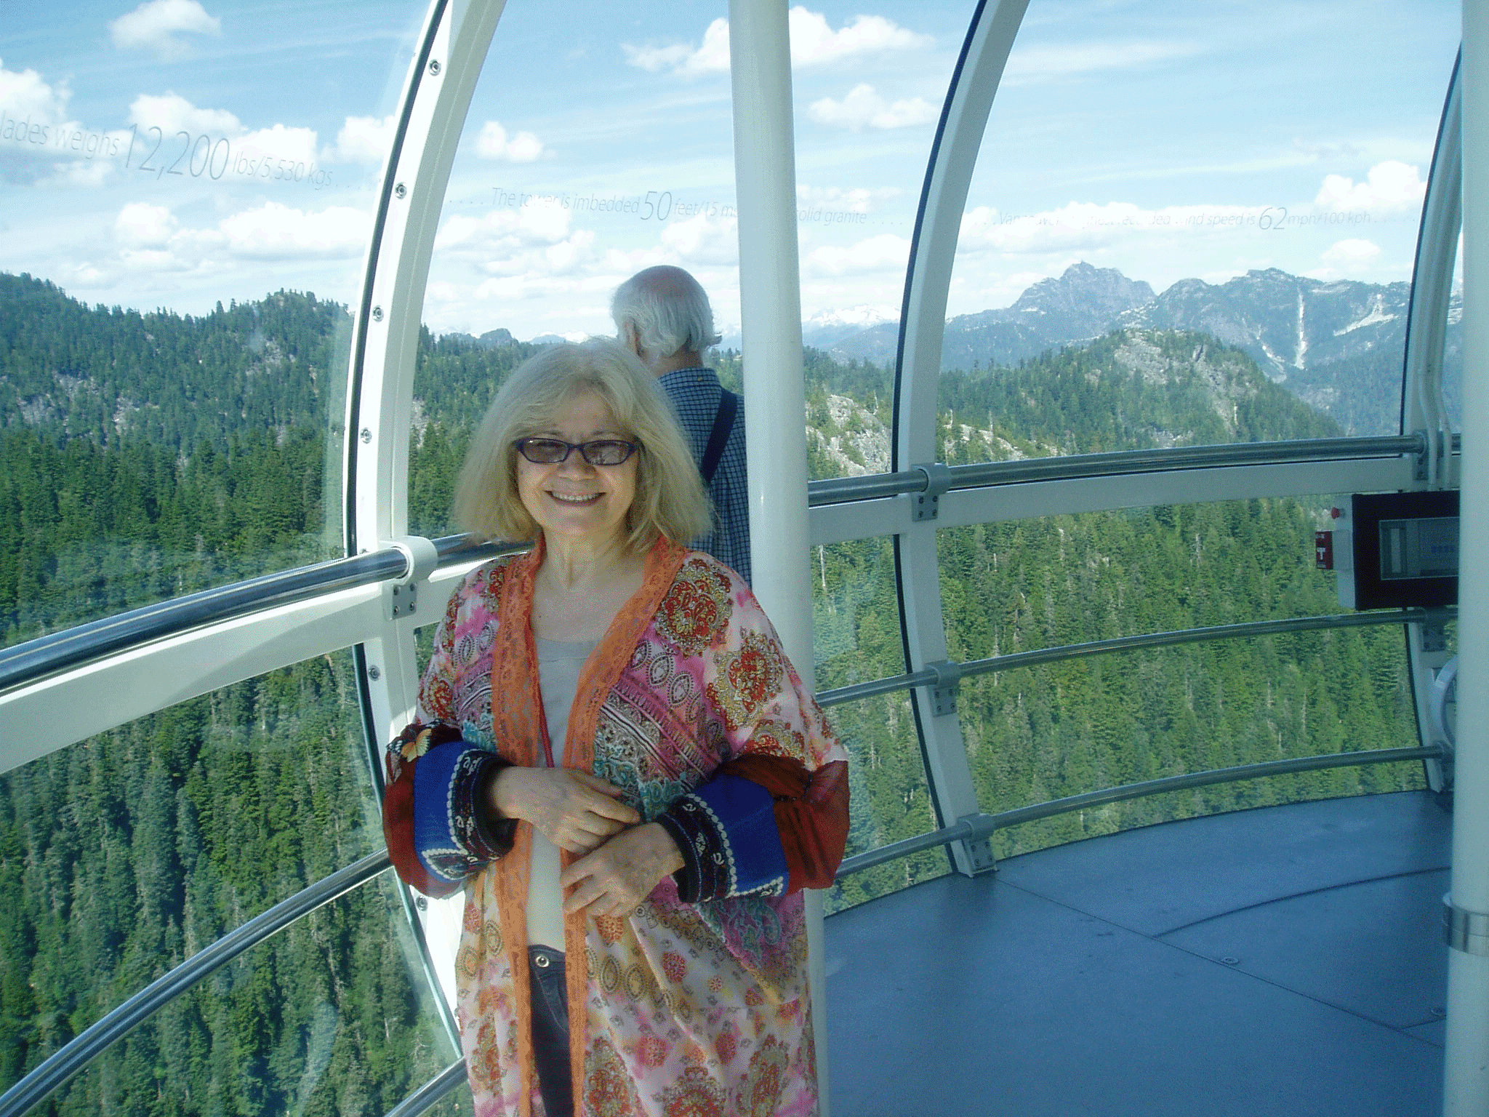
Many immigrants and refugees whose first language is not English end up feeling isolated with very few people to talk to. Even though she sometimes is driven to isolate because of the language barrier, Masi uses her sewing skills through a Kits House volunteer program to facilitate weekly sewing/knitting/crochet classes at her residence. This gives her an opportunity to practice her English. She creates a welcoming environment by providing tea and sharing snacks in an environment which has become a hub of warm conversation. Some participants come only for the conversation and company. Participants enjoy their weekly meetings and are now asking that the classes be held twice a week.
Masi is an avid cook and shares food with staff and residents. She participates in potluck lunches at Kits House where she shares Persian food she has prepared with participants. She and her husband share their love of music with the Kitsilano community by performing violin and drums at events at Kits House when opportunities arise. She has been on several Kits House out-trips in the past year including a trip to Grouse Mountain, Reifel Bird Sanctuary, H.R. MacMillan Space Center and UBC Botanical Gardens.
A key finding in recent research found that those involved in neighbourhood houses have more than one close friend, and it was found seniors have found close friends through their involvement in a neighbourhood house.

